PT LAPI GANESHA UTAMA
In technical partnership with the Institute of Technology Bandung

CERTIFICATION INFORMATION REQUIREMENTS — FILLED WORKING COPY

IECEx/ATEX Certification Information Requirements
Gas Leak Detector (GLD) V2
This document follows, item by item, the section order of the ExCB checklist as it appears in the internal working-draft template (source file below), filled in with GLD's confirmed design data. Task-style annotations from that working draft have been rewritten here as professional status notes.
Document Control
Document title | IECEx/ATEX Certification Information Requirements — Gas Leak Detector (GLD) V2 (Filled Working Copy)
Document no. | LGU/GLD/IECEX-CIR/2026-001
Revision | 0.2
Date | 22 September 2026
Status | Working Document — Draft for Internal Review
Classification | Confidential — prepared for ATEX/IECEx certification body (ExCB) submission
Based on (source template) | IECEx ATEX Certification Information Requirements_Rev18092026.docx (internal working draft, 18 Sep 2026)
Manufacturer | PT Galaksi Megatama Indonesia
Design & development authority | PT LAPI Ganesha Utama (LGU)
Technical partner | Institute of Technology Bandung
Companion document | Dokumen_Teknis_Sertifikasi_GLD_IECEx_ATEX (exhaustive item-by-item status tracking) — authoritative for item-level status where the two documents differ

Scope of this document. This is a compilation of design evidence and an honest readiness assessment against the ExCB checklist, prepared in support of a future submission — it is not itself a certificate and does not constitute self-certification. The product is still at from-scratch development/prototype stage; no finalized, serialized units exist yet.

Revision History
REVISION | DATE | DESCRIPTION
0.1 | 22 September 2026 | Initial issue — filled in against the internal working-draft template (IECEx ATEX Certification Information Requirements_Rev18092026.docx), covering all three sections of the checklist.
0.2 | 22 September 2026 | Total weight corrected to 2.3 kg; IP rating confirmed as IP66; operating humidity confirmed as 10–90% RH non-condensing; cable gland confirmed as M20×1.5 (IP66-rated) — all raised to Final (Section 2.3). Power consumption rounded to 8 W. Removed the ambiguous “no plastic or PVC” parenthetical from the product description (Section 2.1) and generalized “L-bracket” to “bracket” in that same narrative sentence (the dimensioned bracket/U-bolt specification in Section 2.3 is unaffected). “GLD V2 (Version 2)” simplified to “GLD V2”. Layout fix: kept the Section 2.6.b BOM paragraph together across the page break.

Table of Contents
1. Basic Information (Application and Organization) 4
1.1 · Application Form 4
1.2 · Manufacturer's Business License / Company Registration Certificate 4
1.3 · Manufacturer's Organizational Chart and Contact Information 4
1.4 · Address of Manufacturing Plant and Brief Introduction of Production Facilities 5
1.5 · ISO 9001 Certificate, Quality Manual, and Directory of Procedure Documents (for QAR/QAN review) 5
2. Technical Documentation 6
2.1 · Detailed Product Description 6
2.2 · Product Name, Model, and Specification List 6
2.3 · Complete and Clear Functional Description and Technical Parameters (Electrical, Mechanical, etc.) 7
2.4 · Clear Product Photos (Overall and Key Components) 8
2.5 · Description of Intended Use and Installation Environment 9
2.6 · Design and Manufacturing Information 10
3. Sample Information 17
3.1 · Model, Serial Number, and Status of the Sample 17
3.2 · Necessary Test Fixtures or Auxiliary Equipment 17

1. Basic Information (Application and Organization)
Application form (provided by ExCB as a template). Manufacturer's business license/company registration certificate. Manufacturer's organizational chart and contact information. Address of manufacturing plant and brief introduction of production facilities. (If applicable) ISO 9001 certificate, quality manual, and directory of procedure documents (for QAR/QAN review).

1.1 · Application Form
Issued by the ExCB as a template; not yet received.
Status: Template not yet received from the ExCB.

1.2 · Manufacturer's Business License / Company Registration Certificate
The Manufacturer named in this application is PT Galaksi Megatama Indonesia, which holds the Indonesian industrial manufacturing business license (NIB) relevant to fabricating the equipment. PT LAPI Ganesha Utama (LGU) is the design and development authority responsible for the electronics, firmware, and system engineering of the GLD, working with the Institute of Technology Bandung as technical partner.
Particular | Value
Registered legal name | PT Galaksi Megatama Indonesia
Legal form | Perseroan Terbatas (limited liability company), National Private / PMDN, Small Enterprise scale
Business registration number (NIB) | 0510220020593, issued 5 Oct 2022 (OSS system)
Taxpayer ID (NPWP) | 61.126.496.1-427.000, registered 29 Sep 2022
Deed of establishment | Deed No. 52, 22 Sep 2022 (Notary Steffi Alphanie, S.H., M.Kn., Cilegon City)
Ministerial ratification | MOLHR Decree No. AHU-0067398.AH.01.01.Year 2022 (29 Sep 2022)
Registered (domicile) address | Plaza Summarecon Bekasi, Jl. Bulevar Ahmad Yani Kav. K.01, Level 7, Bekasi City, West Java 17143
Relevant KBLI (business scope) | 25119, 25120 (tanks/reservoirs/containers of metal, incl. pressurized gas cylinders), 28221, 25920

Status: Available — legal documents on file with sworn English translations (Fikri Said Obed, S.S., 19 Sep 2026). Legal form/shareholding, business registration, and domicile address confirmed; ISO 9001 certification status addressed separately below.

1.3 · Manufacturer's Organizational Chart and Contact Information
The statutory Board of Directors and Board of Commissioners are known from the deed of establishment:
Position | Name
President Director | Nur Rohman
Director | Antonius Prasetyo
Commissioner | Crisa Andi Sujatmiko

Status: Partially available — statutory officers known. A functional organizational chart (design/production/quality reporting lines) and named ExCB correspondence contacts (certification project contact, technical contact, quality contact) have not yet been provided.

1.4 · Address of Manufacturing Plant and Brief Introduction of Production Facilities
Registered office and NIB-registered production sites of the Manufacturer, PT Galaksi Megatama Indonesia:
Site | Address / Role
Registered office | Plaza Summarecon Bekasi, Jl. Bulevar Ahmad Yani Kav. K.01, Level 7, Bekasi City, West Java
Production site 1 | Jl. Kp. Jatipilar, Cikarang Selatan, Bekasi Regency
Production site 2 | Jl. WR Supratman, Mustikajaya, Bekasi City
Electronics design/assembly (LGU) | Native EasyEDA/JLCPCB project; fabrication/assembly provider and its address to be confirmed in writing

Status: Partially available — registered addresses on file (general metal-fabrication license, KBLI 25120 covers pressurized gas cylinders; not an Ex-specific manufacturing license). Floor area, principal equipment, staffing, and nominal throughput (“brief introduction” requested by the checklist) not yet provided. Production location for serial units has not been fixed — the product is at prototype stage.

1.5 · ISO 9001 Certificate, Quality Manual, and Directory of Procedure Documents (for QAR/QAN review)
Whether the manufacturer currently holds ISO 9001 certification, and if so its certificate number, scope, issuing body, and validity period, is to be confirmed. Quality manual and procedure-document index not yet provided.
Status: To be confirmed / to be provided. Under both IECEx and ATEX schemes, a quality system covering Ex production is expected before certificates are issued (IECEx Quality Assessment Report, or the corresponding production-quality/product-verification route under ATEX) whether or not ISO 9001 is held; the applicable route is to be confirmed with the ExCB.

2. Technical Documentation

2.1 · Detailed Product Description
The Gas Leak Detector (GLD) is an IoT-based, multi-sensor gas leak detection device designed for the early detection of flammable and process gases in oil & gas refinery environments (process units, tank farms, pipe racks, and storage/loading-unloading areas).
Functionally, the GLD integrates eight channels of metal-oxide semiconductor gas sensors (MQ series), an edge-AI microcontroller/processor (ESP32-S3), and a LoRa radio module (star-topology wireless transmission) within a single fixed-point unit installed at locations with gas-leak risk. An on-device AI gas-classification model runs directly on the unit so that detection decisions do not depend on a continuous connection to a central server. When gas concentration exceeds a defined threshold, the unit triggers a local alarm (an integrated visual/audible alarm module) and simultaneously transmits an alarm notification over the LoRa network to the operator dashboard.
The enclosure is designed for hazardous-area deployment at refinery sites, using metal materials (aluminum alloy — ADC12 die-cast grade — and stainless steel) and mounted via a bracket to existing structures without drilling or welding. The current production power configuration is continuous 24 VDC, supplied via an AC/DC adapter (220 VAC/50 Hz → 24 VDC) connected to the site electrical supply.
Important: this design-intent description does not constitute a claim that the enclosure has passed testing or has been Ex-certified. The explosion-protection scheme, gas group, temperature class, and target installation zone are addressed in Section 2.5.

2.2 · Product Name, Model, and Specification List
Field | Value
Product name | Gas Leak Detector (GLD)
Model / version | GLD V2
Manufacturer | PT Galaksi Megatama Indonesia
Design & development authority | PT LAPI Ganesha Utama (LGU)
Technical development partner | Institute of Technology Bandung — IoT Laboratory & Physics Laboratory
Program owner | PT Pertamina Patra Niaga (initial deployment site: Refinery Unit IV, Cilacap)
Primary function | Acquisition of 8-channel gas sensor data and LoRa transmission
Microcontroller | ESP32-S3-WROOM-1U-N16R8
LoRa radio module | E22-900MM22S
Dimensions (L×W×H) | 200 × 90 × 290 mm
Enclosure material | Aluminum alloy (ADC12 die-cast) + stainless steel

2.3 · Complete and Clear Functional Description and Technical Parameters (Electrical, Mechanical, etc.)
Functional workflow (normal operating mode): sense → process → transmit. Each of the eight gas sensors continuously samples ambient conditions → data is normalized and classified by the on-device AI model (ESP32-S3) → the result is transmitted over the LoRa network (star-topology transmission) at a configurable interval, or immediately (event-driven) when an alarm condition is detected. Gas alarms are triggered through two parallel channels: a local visual/audible alarm module on the unit itself, and a push notification transmitted over the LoRa network to the dashboard.
Electrical Parameters:
Parameter | Specification
Input voltage | 24 VDC (continuous)
Source adapter (if AC-fed) | 220 VAC / 50 Hz input → 24 VDC output
Internal voltage rails | 5 VDC (sensor/heater circuitry), 3.3 VDC (ESP32-S3 logic)
Measured power consumption | 8 W @ 24 VDC (≈ 0.33 A) — production configuration
Cable/PSU sizing margin | ≥ 1 A per unit (sizing margin only; actual draw is well below this)
Power cable | 2-conductor, labeled L+/L− (positive/negative of the 24 VDC supply), each conductor ≈ 0.75 mm diameter
Electrical protection | Resettable PPTC fuses (F1/F2), TVS/ESD suppression diodes, Schottky diodes on power rails

Sensor and Communication Parameters:
Parameter | Specification
Gas sensor array | 8 channels, metal-oxide (MQ-2, MQ-3B, MQ-4, MQ-5, MQ-6, MQ-7B, MQ-8, MQ-135)
Signal acquisition | 24-bit multi-channel ADC (ADS1256IDBR, 30,000 SPS), 500 ms scan interval
AI gas-classification model | On-device classifier — 3 classes: Clean Air, LPG, H₂; alarm at confidence ≥ 30%. Does not yet cover CO₂, Benzene, CO, or H₂S
Temperature/humidity telemetry | SHT40 sensor (auxiliary)
LoRa radio | E22-900MM22S, star-topology transmission, 920–923 MHz ISM band (Indonesia)
Data transmission interval | Configurable, default 10 s; alarm events transmitted immediately
RS-485 / Modbus interface | Read-only Modbus RTU slave, 9600 bit/s 8N1, Unit ID 1 (THVD1410DR) — 8 read-only registers for external integration; not used for product control

Mechanical Parameters:
Parameter | Specification | Status
Dimensions (L×W×H) | 200 × 90 × 290 mm | Final
Total weight | 2.3 kg | Final (project-confirmed, not yet calibration-verified)
Enclosure material | Aluminum alloy (ADC12 die-cast) + stainless steel | Final (see caveat below)
Mounting method | Bracket + U-bolt (2″/DN50), no drilling/welding | Final
Ingress protection (IP rating) | IP66 | Final
Cable entry (gland) | M20×1.5 cable gland (IP66-rated), power cable L+/L−, ≈ 0.75 mm/conductor | Final (see note below)
Antenna mounting | External, SMA male connector | Final
Operating temperature range | −40°C to +85°C (ambient) | Final (project-confirmed)
Operating humidity range | 10–90% RH, non-condensing | Final (see note below)

Caveat on the ADC12 enclosure grade. ADC12 is the material called out on a Chinese enclosure-component manufacturer's drawing for a related die-cast sub-component (“Universal Base,” part no. BP18-1Z, from the same casing-partner supply chain — Section 2.6.a); the “GLD ATEX CASE v3” drawing of the main enclosure body itself does not carry its own material callout. ADC12 has been confirmed as the enclosure grade on the basis that the same casing manufacturer's die-cast product line uses this alloy consistently — an extrapolation from the supplier's sub-component drawing, not a direct material callout on the main enclosure drawing. This should be verified against the casing partner's own datasheet for the enclosure body before formal ExCB submission.

Caveat on cable gland and humidity range. Cable gland: M20×1.5 matches the thread size used on the BP18-1Z reference drawing from the same casing manufacturer (Section 2.6.a) and is a standard, IP66-rated gland size well suited to a 2-conductor cable with ≈0.75 mm conductors — selected by engineering judgment from that reference, not from an independent gland datasheet or fit test on GLD's own enclosure. Humidity range: 10–90% RH non-condensing is a standard industrial-electronics rating, matched to the range specified by a comparable certified diffusion-type gas detector (New Cosmos KD-12/KD-12R, cited in the companion Instruction_Manual_GLD, Section 13) — it has not been independently measured or tested for GLD. Both should be confirmed by test/fit-check before formal ExCB submission.

Three operating modes are distinguished at firmware level:
Mode | Purpose | Use restriction
Inference | Normal gas-class inference and alarm operation | Production operating mode after commissioning
Dataset | Engineering / data-collection activity | Not a substitute for approved detection operation
Nulling | Sensor baseline / calibration activity | Clean air only; approved procedure; requires complete 8/8 result

2.4 · Clear Product Photos (Overall and Key Components)
The photographs below were taken directly from the Node Sensor (GLD) V2 prototype unit.
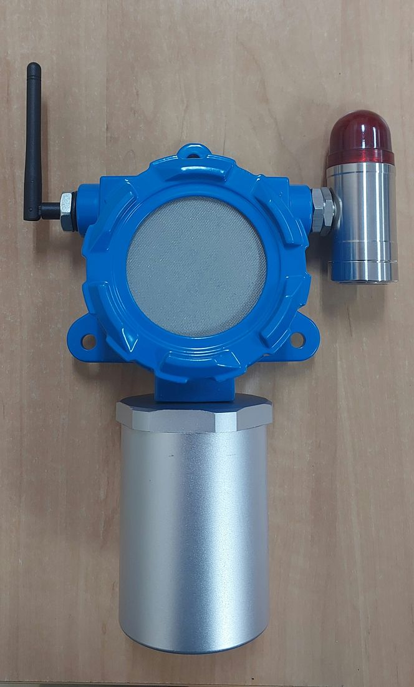
Assembled unit — motherboard, sensor module, mesh cover, casing, external antenna, and local alarm module.
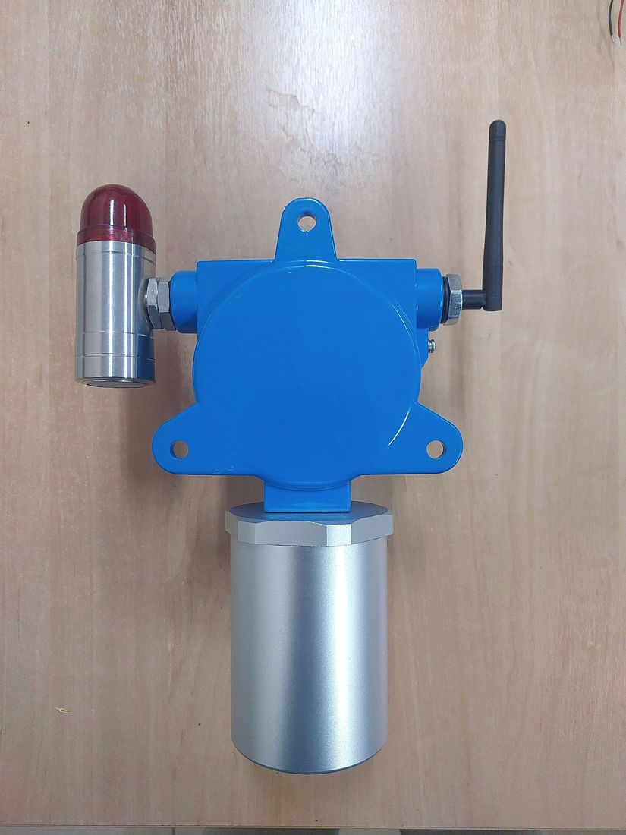
Enclosure, rear view — mounting flange and cable-entry area.

2.5 · Description of Intended Use and Installation Environment
The GLD is intended for continuous, fixed-point monitoring of flammable and toxic gas leaks in oil & gas refinery hazardous areas: process units, tank farms, pipe racks, and loading/unloading areas.
Parameter | Value | Status
Gas group | IIC | Internal recommendation, not an ExCB decision
Temperature class | T4 (≤135°C) | Target — hot-spot verification outstanding (Section 2.6.f)
Area classification | Zone 1, Equipment Category 2G, Group II | Requested — subject to ExCB assessment
Type of protection | Not yet selected — Ex d, Ex e, and Ex i under evaluation | Open

These classification parameters are the applicant's proposal, recorded here as a request, not as an agreed or granted classification. Cluster Head and Gateway devices are assumed to always sit in a safe area (project assumption, not the result of a formal area-classification study by Pertamina).

2.6 · Design and Manufacturing Information

2.6.a · Complete Drawings (Assembly, Component, Electrical Schematic, PCB Layout, Enclosure Structure, Junction Box, Terminal, Grounding)
An electrical schematic capture and a corresponding 9-sheet block-diagram set exist for the GLD V2 main board, exported from the native EasyEDA/JLCPCB source project, with pin-to-net traceability evidence.
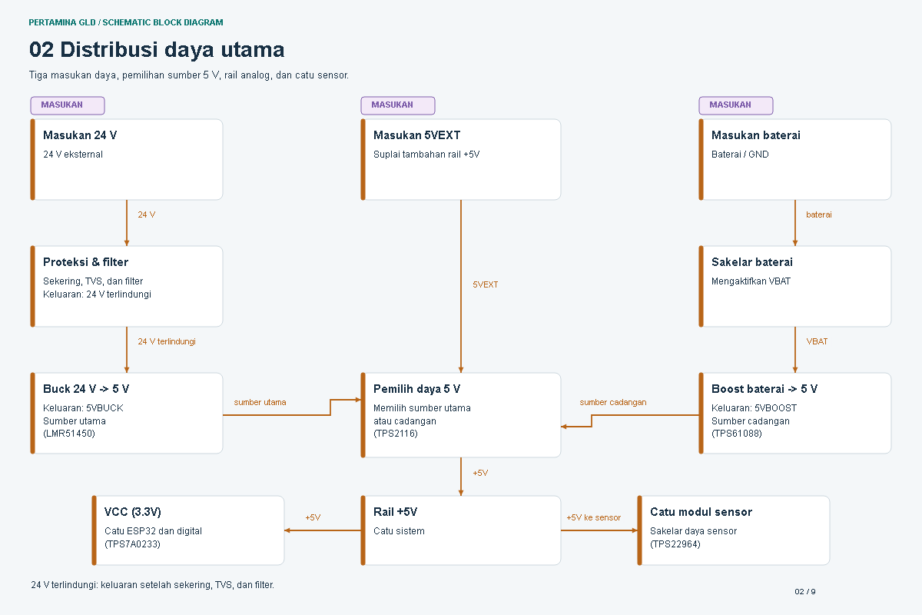
Schematic block diagram, sheet 2 of 9 — main power distribution.
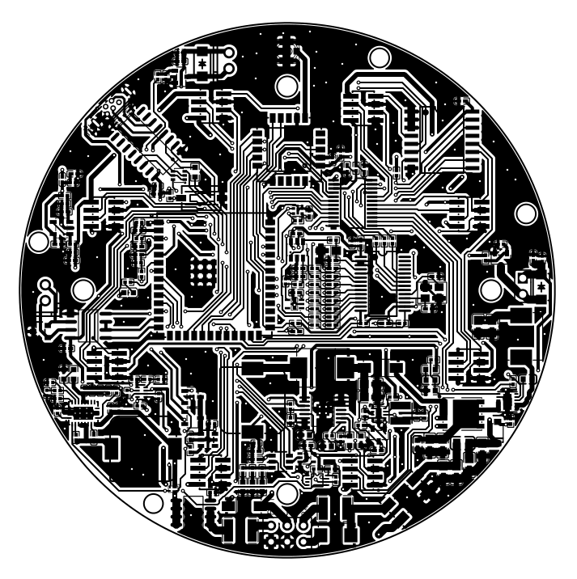
Main board PCB layout (top copper) — native EasyEDA/JLCPCB export, production-intent board.
A dimensioned mechanical drawing exists for the enclosure's external envelope and mounting hardware, drafted from a solid CAD model (STEP format, millimeter units):
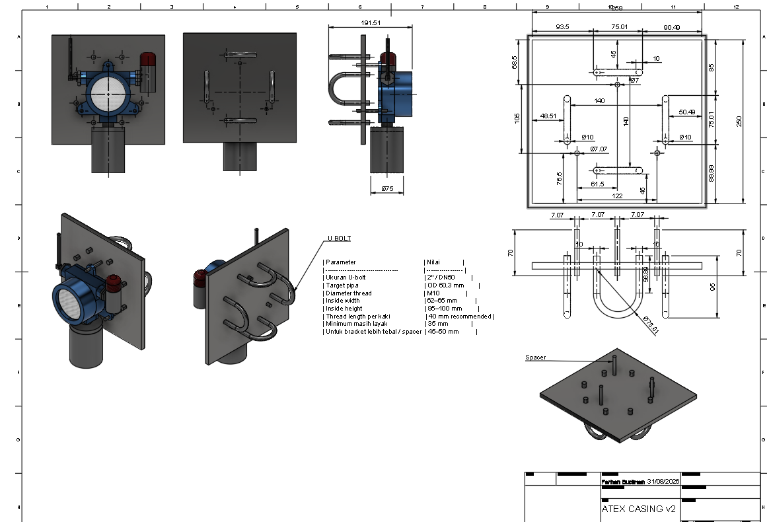
Enclosure envelope & L-bracket/U-bolt mounting assembly — dimensioned drawing sheet (drafted 31 Aug 2026, from a STEP solid model).
A separate, internal contingency/alternate enclosure design (“GLD ATEX CASE v3”) exists in parallel with the primary commercial-enclosure sourcing path referenced in Section 2.3:
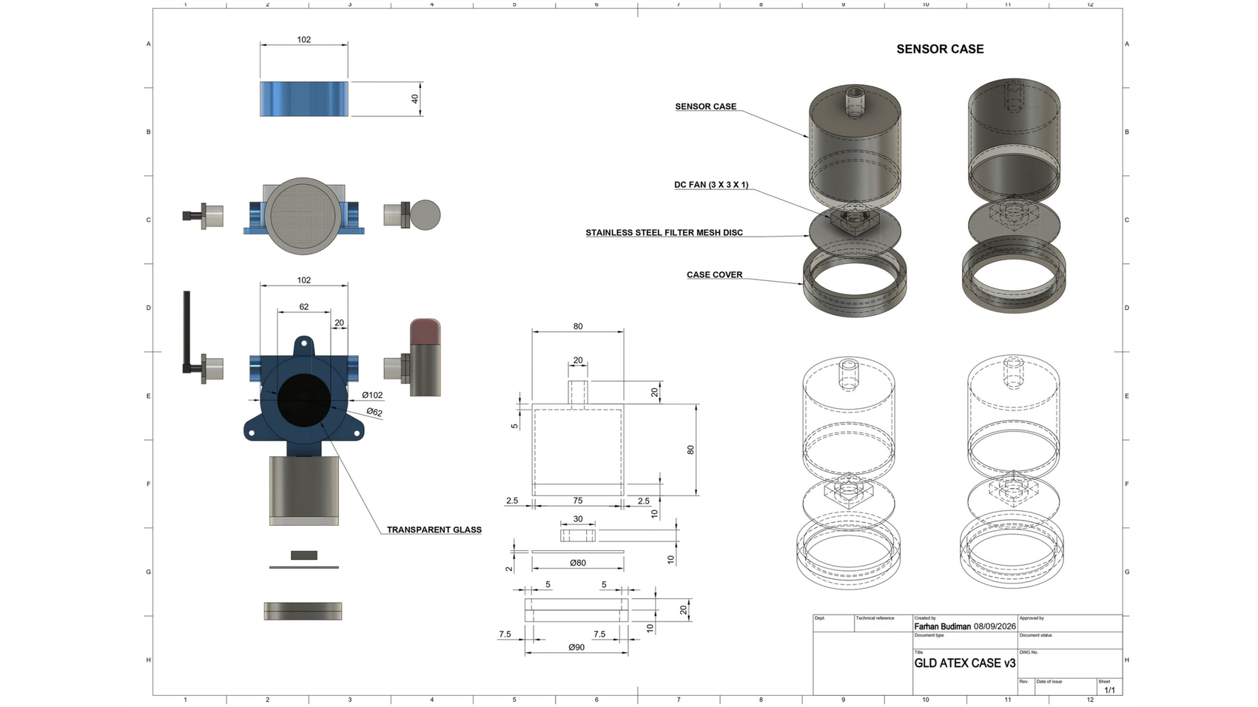
“GLD ATEX CASE v3” dimensioned drawing sheet (Farhan Budiman, 8 Sep 2026) — internal contingency/alternate enclosure design, not the confirmed production enclosure.
A candidate junction-box/terminal sub-component drawing has also been received via the casing partner's supply chain (Chinese enclosure-component manufacturer):
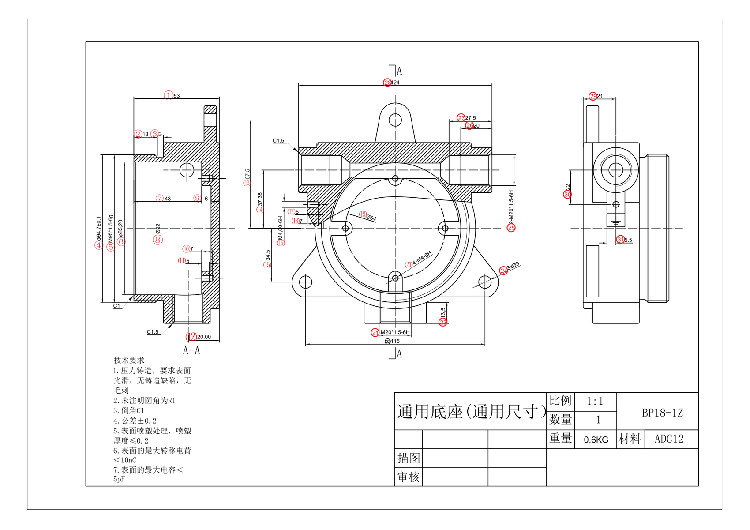
“Universal Base” BP18-1Z — supplier reference drawing (ADC12 die-cast aluminum alloy, 0.6 kg). Candidate component under evaluation; footprint does not match GLD's main enclosure, not yet confirmed as part of GLD's design.
Drawing type | Status
Electrical schematic / block diagram | Partially available — not yet a released, revision-controlled drawing with a formal drawing number
PCB layout | Partially available — native export and 3D model exist; not yet a released, toleranced drawing
Assembly drawing | Partially available — covers external envelope and mounting hardware, not internal PCB/component assembly sequence
Component drawing | Not yet available
Enclosure structure drawing (gap, length, volume) | Partially available — external envelope dimensioned; Ex-d-specific flame-path parameters not yet called out
Junction box / terminal / grounding connection drawings | Candidate reference only — BP18-1Z drawing above, not yet confirmed as part of GLD's design

2.6.b · Bill of Materials (BOM) for Key Components Affecting Explosion-Proof Safety
A complete, itemized electronic-component BOM exists for both boards, exported directly from the EasyEDA/JLCPCB source project (manufacturer, manufacturer part number, and LCSC supplier part number per line item): 89 line items / 214 placed components on the main board, 14 line items / 24 placed components on the sensor board. Full listing maintained in Dokumen_Teknis_Sertifikasi_GLD_IECEx_ATEX, Section 2.6.b.
Status: Partially available. The explosion-safety-relevant subset the checklist actually asks for (enclosure, gasket, cable entry device, battery, potting compound, and the gas sensor itself, with material grade and Ex/UL/CCC certification for each) remains not yet compiled — these are mechanical/safety parts, not electronic components, and sit with the Manufacturer, PT Galaksi Megatama Indonesia. The gas sensor itself (MQ2) is sourced outside the LCSC supply chain, without a manufacturer/LCSC part reference; its Ex status is not yet verified.

2.6.c · Material Specification Sheets / Datasheets (Non-Metallic Materials)
Datasheets or supplier conformity declarations for non-metallic materials (enclosure components, seals, insulators, potting compounds) — covering heat/cold resistance, anti-aging, anti-static, flame retardancy, CTI value, and chemical resistance — have not yet been collected.
Status: Not yet available, pending the enclosure design and material selection with the casing partner. Partial candidate data: the BP18-1Z reference drawing (Section 2.6.a) specifies a powder-coating surface treatment with electrostatic-safety parameters directly relevant to this item — maximum surface charge transfer <10 nC and maximum surface capacitance <5 pF (coating thickness ≤0.2 mm), consistent with IEC 60079-0 coating requirements — but this describes a supplier's candidate component, not a confirmed datasheet for GLD's own enclosure finish.

2.6.d · Manufacturing Process Description
A description of manufacturing processes relevant to explosion-protection safety (enclosure machining accuracy control, explosion-proof surface treatment, welding, potting, die-casting, bonding) has not yet been documented.
Status: Not yet available — this describes the Manufacturer's (PT Galaksi Megatama Indonesia) process, not an internal electronics process.

2.6.e · Explosion-Protection Calculations and Explanations (if applicable)
Calculations depend on the explosion-protection concept selected (e.g., Ex d, Ex e, Ex i), which has not yet been confirmed with the ExCB, and on final enclosure geometry.
Status: Not yet available — pending protection-concept confirmation and final enclosure design.

2.6.f · Temperature Group Calculation (Hottest-Point Temperature Estimation)
No hottest-point temperature calculation or measurement has been performed for this product. As general context: MQ-series metal-oxide gas sensors operate using an internal heating element, a class of sensor commonly associated with published operating temperatures in the approximate 200–400°C range — however, this is a general characteristic of the sensor class, not a measured value for the specific sensor models, drive circuitry, and enclosure configuration used in this product.
Status: Not yet available. A worst-case hot-spot measurement is the top-priority action required to substantiate the recommended T4 classification.

2.6.g · Usage and Installation Instructions (Draft)
Safety warnings:
- Only trained and authorized personnel may install, commission, operate, inspect, or maintain the detector.
- Isolate and verify the 24 VDC supply before opening the enclosure or changing wiring. Apply the site lockout/tagout procedure.
- Use only the approved production power arrangement: 24 VDC.
- Perform alarm tests with appropriate site controls and hearing protection where audible devices are connected.
- Perform sensor nulling only in confirmed clean air. Accept the operation only when all eight sensors report a complete 8/8 result; otherwise correct the cause and repeat.
- Do not drill, weld, enlarge cable entries, bypass protective devices, or modify the enclosure without written engineering and Ex approval.
- Remove the unit from service if there is visible damage, water ingress, an unresolved sensor fault, failed alarm proof, or a loss of protective-earth continuity.
Detailed installation requirements:
Cable entry method: use only cable glands, adaptors, blanking elements, and seals approved for the final protection concept, certificate, thread form, IP rating, cable outer diameter, and installation temperature. Do not create new entries, enlarge an entry, leave unused entries open, or substitute a general-purpose gland. Maintain the manufacturer sealing/clamping sequence and record the installed component part number and certificate reference.
Torque requirements: torque values shall comply with the approved enclosure, terminal, cable-gland, and blanking-plug manufacturer instructions (specific torque figures not yet available, dependent on final hardware selection).
Grounding requirements: connect the enclosure to the approved protective-earth system using the designated grounding terminal; verify continuity before energization.
Cleaning requirements: isolate the equipment per site procedure and use a soft lint-free cloth lightly dampened with clean water or an approved mild cleaner; do not use abrasives, aggressive solvents, dry compressed air, high-pressure spray, or tools that can damage the enclosure, gasket, label, antenna, or cable entries; keep liquid out of all openings.
Operating instructions and maintenance requirements:
Before each operating period, check power, enclosure condition, diagnostic status, communication status, and the absence of active faults. Treat an alarm as a real process-safety event until the site response procedure establishes otherwise. Do not change firmware, model files, alarm thresholds, or calibration parameters from the field without controlled approval and a documented rollback path.
Status: Partially available (draft) — not yet consolidated into an Ex-specific installation and operation manual for ExCB review; also feeds the standalone Instruction_Manual_GLD deliverable.

2.6.h · Nameplate Information (must include all ATEX-required marking information)
Nameplate artwork cannot yet be finalized: it depends on the certificate number, protection marking, temperature class, ambient range, IP rating, and serialization scheme, none of which has been assigned yet.
Status: Not yet available.

2.6.i · Ex Component Certificates
No components in this design currently hold an Ex component certificate. The processing unit (ESP32-S3-WROOM-1U-N16R8) and the communication module (E22-900MM22S) hold RF/EMC certifications (FCC, TELEC, CE, RoHS) — these are not Ex component certificates and do not satisfy this item.
Status: Not yet available.

3. Sample Information

3.1 · Model, Serial Number, and Status of the Sample
No formal sample register or dossier for ExCB submission has been established. Internal engineering and bench testing reference the “GLD V2” board configuration under firmware environment gld_v2; a discrete unit serial-numbering scheme for certification samples has not yet been implemented.
Status: Not yet available. The product is still being built from scratch at prototype/development stage; no finalized, serialized unit yet exists to register as a submission sample.

3.2 · Necessary Test Fixtures or Auxiliary Equipment
Equipment anticipated for commissioning and bench-level functional verification:
Equipment | Purpose
Regulated 24 VDC power supply | Provides a stable 24 VDC supply during commissioning and functional testing.
Digital multimeter | Measures actual voltage, verifies polarity and continuity, supports grounding/bonding verification.
Calibrated gas source / gas test kit | Provides the required gas types to verify correct sensor response.
Gas test chamber | Provides a controlled gas-exposure environment for reproducible test conditions.
Alarm load / relay simulator | Verifies that the alarm output and connected electrical load operate correctly.
LoRa peer / gateway | Verifies that data transmitted by the GLD is successfully received by the intended system.
Laptop and approved software | Reviews diagnostic information, configuration, logging, firmware identification; stores commissioning and test evidence.
Calibrated torque screwdriver | Ensures glands, terminals, enclosure fasteners, and grounding connections are tightened to approved torque values.

Status: Draft plan only — not yet executed, and not evidence of ExCB/laboratory test readiness.

This is a working document, filled in against the internal working-draft template (IECEx ATEX Certification Information Requirements_Rev18092026.docx) supplied for this purpose. It follows that template's own section order rather than the more exhaustive item-by-item status tracking maintained in Dokumen_Teknis_Sertifikasi_GLD_IECEx_ATEX — the two documents are maintained in parallel and should stay consistent; treat the exhaustive tracking document as authoritative for item-level status where they differ. Data sources: the official product technical datasheet (Institute of Technology Bandung, Revision 4.0), internal technical specification documentation, EMC parameter measurement data, EasyEDA/JLCPCB design exports, and PT Galaksi Megatama Indonesia's legal documents.

